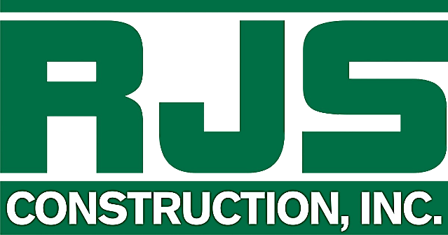

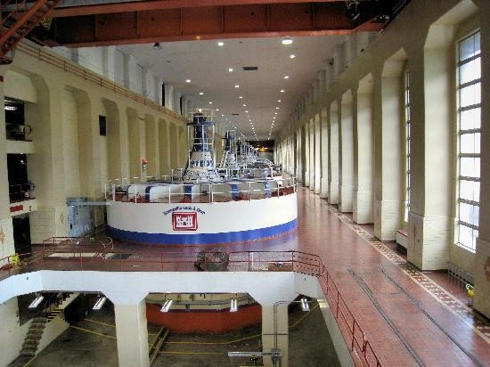
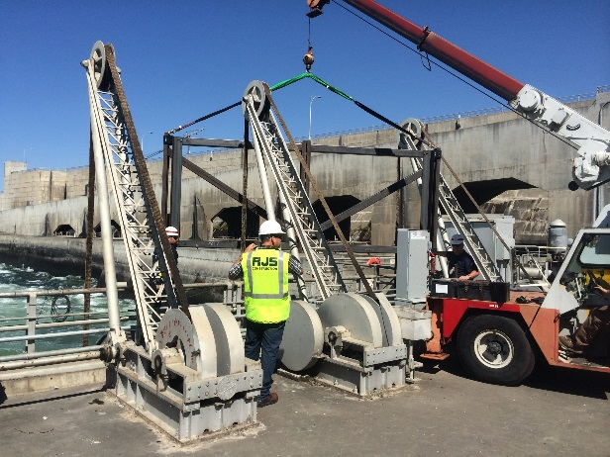
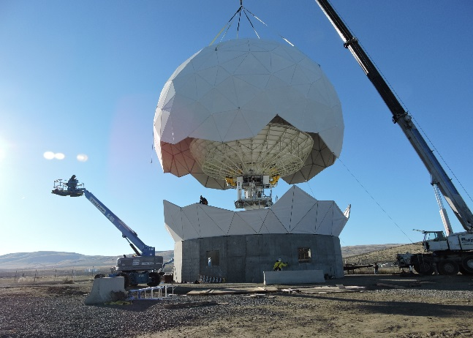

Statement of Qualifications

RJS Construction, Inc.
Celebrating 30 Years as a Full-Service General Contractor
Providing Quality Construction and Design-Build Services
A Woman/Native American Owned Small Business
8(a), SDB, EDWOSB

Contents
Company Introduction 2
Multiple Award & IDIQ Contracts 3
NAICS Codes 4
Federal Clients Served 5
Geographic Reach 5
Management & Support 6
Subcontractors & Suppliers 8
Safety 9
Design-Build 10
Quality Control 11
Customer Satisfaction 12
Projects 13

Company Introduction
RJS Construction, Inc. is a Woman/Native American Owned Small Business, 8(a), SDB, EDWOSB full-service general contractor founded in 1990 by Shannon & Richard Sevigny. Since 1990, RJS has successfully delivered general and design-build construction projects across the Western United States. Our reputation has been built on the quality of our construction services and our ability to develop and maintain sound client relationships. These strong relationships have resulted in over 90% of our clients in the past ten years have been return customers seeking our expertise. We firmly believe this client loyalty is a testament to our commitment to safety, our dedication to quality and an understanding of our clients’ needs.

Below are a few items that differentiate RJS from our competitors:
- 30-years of successful design-build construction experience
- Only one time-loss injury in 30 years of business
- Bonding Capacity: $25 Million Single, $50 Million Aggregate
- Successful federal project history including military bases, dams, land ports of entry, airfields, roads, docks, SCIFs, labs, tribal reservations, and medical facilities.
- Experience includes horizontal and vertical construction, industrial, new construction and occupied space renovation.
- The ability to self-perform all phases of rough and finish carpentry, steel erection, concrete, abatement and site & heavy civil work.
- RJS has a proven track record of successfully providing a broad range of maintenance, repair, renovation, and new construction services for Task Orders under multiple award contracts with various federal agencies.

General Information:
RJS Corporate: CAGE Code: 5L4J4 DUNS Number: 623879905
Colorado CAGE Code: 74QJ8 DUNS Number: 079393223
Portland: CAGE Code: 7WBS6 DUNS Number: 080713104
Primary NAICS Code: 236220-Commercial & Institutional Building Construction
Thank you for reviewing our statement of qualifications and for the opportunity to introduce RJS Construction, Inc.
Best Regards,
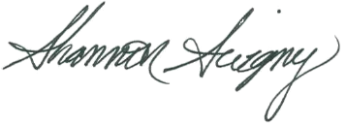

Shannon Sevigny - President/CEO RJS Construction, Inc.

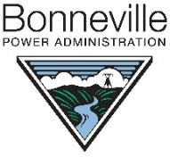
Multiple Award & IDIQ Contracts
Bonneville Power Administration:

- BPA-NW Region Alter/Repair MATOC (Full & Open)
Department of Homeland Security/Customs & Border Protection:
- DHS/CBP-Facility Operation & Repair 8(a) IDIQ
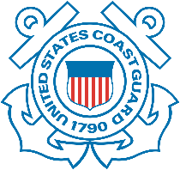
US Coast Guard:
- USCG-Emergency Repairs 8(a) BOA
US Army Corps of Engineers:
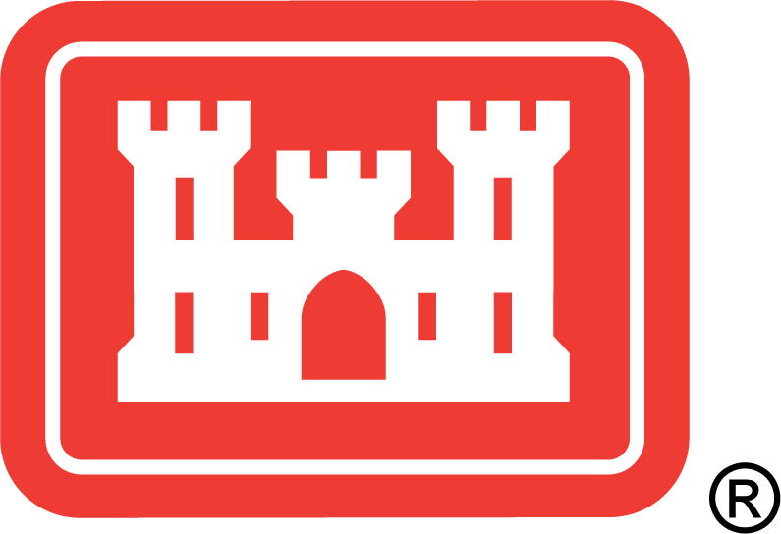
- USACE-Engineers-Omaha Front Range D-B Roofing SB MATOC
- USACE-Design-Build LPOE SB MATOC
General Services Administration:
- GSA Regional Historical Preservation IDIQ
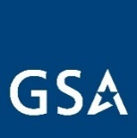
- GSA R10 - SESC, Spokane 8(a) MATOC
- GSA – Western Construction MATOC
- GSA – Southern Construction MATOC

Bureau of Land Management:
- BLM – Construction Services (vertical) SB MATOC
US Department of Agriculture:

- USDA Forest Service-Construction & Facility Maintenance Service IDIQ

National Park Service:
- NPS Northern Rockies-DB Services 8(a) MATOC
- NPS Northern Rockies-General Construction Historic & Non-Historic MATOC

Indian Health Services
- IHS Billings/Portland Construction MATOC
US Air Force:
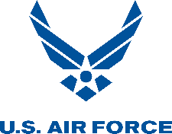
- USAF Reg 10 Fairchild AFB-8(a) MATOC - Completed
National Renewable Energy Laboratory:

- NREL-Design-Build Services TOA - Completed
Western Area Power Administration

- Upper Great Plains MATOC - Completed

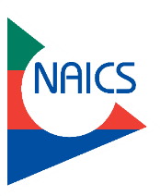
NAICS Codes
RJS has current or completed projects under the following NAICS codes:
Primary Code: 236220-Commercial & Institutional Building Construction

Secondary Codes:
- 221114-Solar Electric Power Generation
- 221115-Wind Electric Power Generation
- 221117-Biomass Electric Power Generation
- 221310-Water Supply & Irrigation Systems
- 236116-New Multifamily Housing Construction (except Operative Builders)
- 236210-Industrial Building Construction
- 237110-Water and Sewer Line and Related Structures Construction
- 237120-Oil and Gas Pipeline and Related Structures Construction
- 237130-Power and Communication Line and Related Structures Construction
- 237310-Highway, Street, and Bridge Construction
- 237990-Other Heavy and Civil Engineering Construction
- 238110-Poured Concrete Foundation and Structure Contractors
- 238120-Structural Steel and Precast Concrete Contractors
- 238160-Roofing Contractors
- 238210-Electrical Contractors and Other Wiring Installation Contractors
- 238220-Plumbing, Heating, and Air-Conditioning Contractors
- 238910-Site Preparation Contractors
- 325510-Paint and Coating Manufacturing
- 332312-Fabricated Structural Metal Manufacturing
- 333415-Air-Conditioning and Warm Air Heating Equipment and Commercial and Industrial Refrigeration Equipment Manufacturing
- 562910-Remediation Services
- 811310-Commercial and Industrial Machinery and Equipment (except Automotive and Electronic) Repair and Maintenance

Federal Clients Served

US Army Corps of Engineers
Customs & Border Protection
Department of Homeland Security
US Marshals
General Services Administration
National Park Service
National Renewable Energy Laboratory
Social Security Administration
Western Area Power Administration
Bureau of Indian Affairs
Immigration and Naturalization Services
US Postal Services
Joint Base Lewis McChord-YTC
US Air Force Academy
Bonneville Power Administration
Bureau of Land Management
US Forest Service
Federal Aviation Administration
Naval Facilities Engineering Command
Fairchild Air Force Base
Mountain Home Air Force Base
WA State Department of Enterprise Services
Indian Health Services
National Institute for Science and Technologies

Geographic Reach
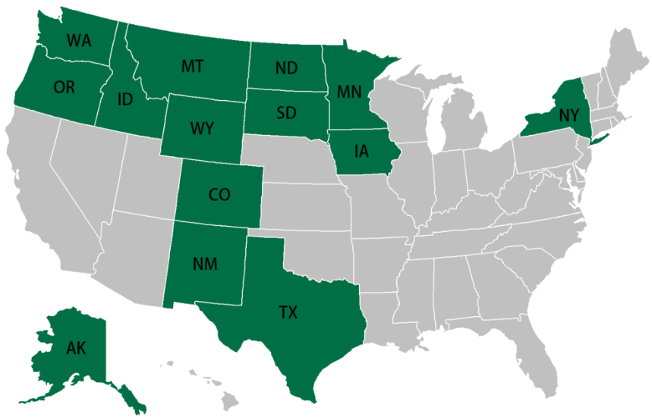
RJS has successfully completed projects in fourteen states throughout the country. Many of these projects have been located in remote areas where standard supplies were hours away. Our team is experienced in the pre-planning required to meet these types of logistical challenges. We know what it takes to arrive at remote and/or locations new to RJS and assemble the field crews, subcontractors and suppliers required to get the job done.
Completing projects at various locations has provided us knowledge of subcontracting availability & pricing and has also given us invaluable experience in how to navigate the procurement process in new and diverse locations. We have learned that successful execution of projects in remote locations requires an extraordinary amount of pre-planning and preparation. If not adequately considered, things that might be taken for granted on a typical construction project: access to labor, subcontractors, materials, equipment, and even meals and lodging, can have significant impacts to both budget and schedule performance. Key strategies for accomplishing adequate preplanning and preparation are to initiate it early in the project lifecycle, to be disciplined about implementation, and to continuously evaluate and reevaluate the information. If necessary, we modify the plan throughout the project as new and/or better information becomes available. RJS prides itself on early and thorough pre-planning in the proposal stage and considers this as one of the major contributing factors to our extremely low rate of contractor generated change orders. Traveling-labor, materials, subcontractors, and equipment can include both direct and indirect impacts to cost and schedule.
If qualified subcontractors cannot be located, RJS has the ability to self-perform many trades including rough and finish carpentry, steel erection, concrete work, low and medium voltage electrical, and heavy civil & site work. With our subcontractor network and self-performance capability, the RJS Team can complete projects on time and within budget.

Management & Support
Every Tuesday afternoon, RJS holds a mandatory, firm-wide meeting which is hosted in our corporate office. Staff members in our satellite offices attend virtually via GoToMeeting and Superintendents call in from the field as needed. Employees have the opportunity to report on and/or request support in financial, management, or technical issues. These weekly team meetings are the primary means by which we hold general discussions regarding safety, quality control, resource management, and where we share general information about potential and current projects.
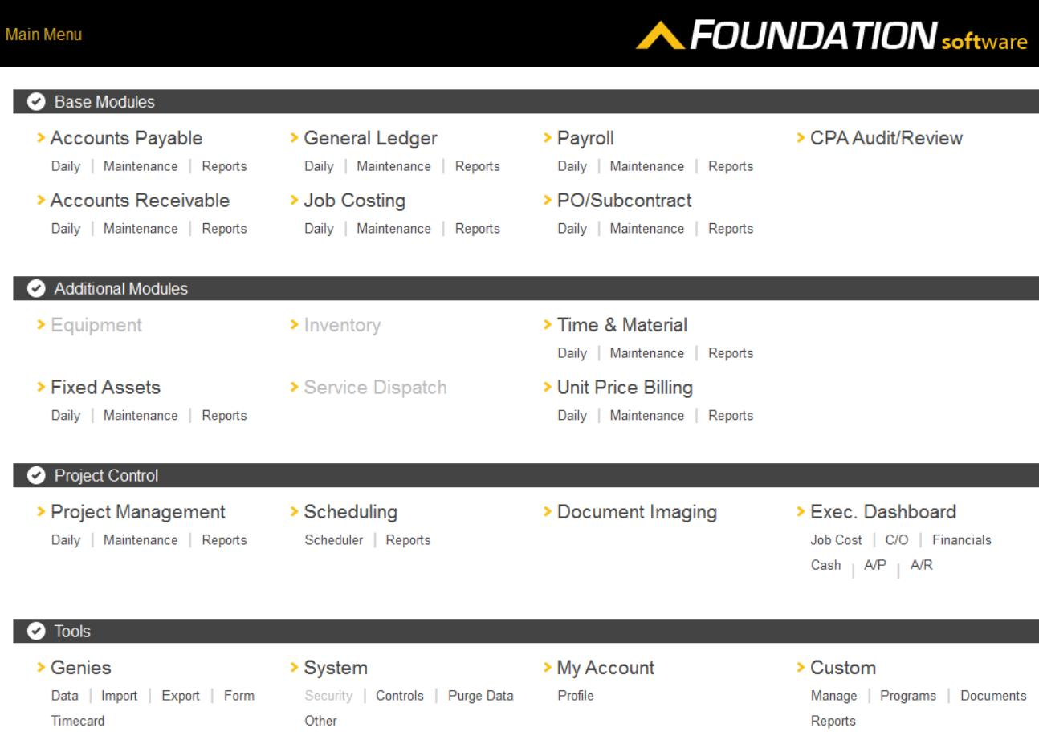
For financial management support, RJS utilizes Foundation Software- a fully integrated, project management accounting system - that allows the corporate office to know the status of each project daily. Site superintendents submit purchase orders, committed costs, and payroll items to be entered into Foundation so that RJS headquarters can have a real-time view of each individual project underway at every stage of the process.
To facilitate management support, RJS operates through a highly secure central server, and duplicate backup server. Project management staff and site supervisors are able to securely connect to the server via their RJS issued technology and therefore have the ability to upload and update information pertaining to individual projects in real time. This maximizes opportunities for secure communication and personal input amongst the entire team and provides security for sensitive documents and information.

More detailed information for current projects is shared internally via Project Status Reports that are completed and posted each day by superintendents and submitted as applicable to the Project Managers or the Director of Operations. These reports provide a quick executive overview of the status of the project and focus specifically on scope, schedule, cost, risks, and quality.
The RJS Client Communications Plan sets the communications framework for any given project. The Communications Plan serves as a dynamic guide that will be updated as communication needs change. The plan identifies and defines the roles of persons involved in the project and includes a matrix which maps the communication requirements. Upon notification of contract award, a project team directory will be distributed to all stakeholders directly involved in the contract.

The RJS Project Manager will take a proactive role in ensuring effective communications with the client for the duration of the contract. The Project Manager will maintain regular contact with the client as needed to ensure information flows effectively and efficiently on all Task Orders. Our proposed communications requirements are contained in the Communications Matrix presented below. This Communications Matrix is used on a multiple award contract as the guide for what information is to be communicated, who are the instigators and recipients of communication, and when the communication is to take place.
To provide technical support, the project team will determine the communication methods and technologies to be utilized based on several factors. These include: stakeholder communication requirements, available technologies (internal and external), and organizational policies and standards.
Communication Type | Description | Frequency | Format | Participants/ Distribution | Deliverable
Weekly Status Report | Email summary of project status | Weekly | Email | Project Sponsor, Team & Stakeholders | Status Report
Weekly Project Team Meeting | Meeting to review action register & status | Weekly | In Person | Project Team | Updated Action Register
MATOC  Project Monthly Review (PMR) | Email  Project Monthly Review | Monthly | Email | Project Sponsor, Team & Stakeholders | Status Report
Task Order  Project Monthly Review (PMR) | Email  Project Monthly Review | Monthly | Email | Project Sponsor, Team & Stakeholders | Status Report
Project Gate Reviews | Present closeout of project phases & kickoff next phase | As Needed | In Person/  Teleconference | Project Sponsor, Team & Stakeholders | Phase completion report & phase kickoff
Technical Design Review | Review of any technical designs or work associated with the project | As Needed | In Person/  Teleconference | Project Team | Technical Design Package

These management tools enable all team members, both in the office and on the field to access information in a timely manner that facilitates project flow and productivity.

Subcontractors & Suppliers
Subcontractor Sourcing: RJS maintains a subcontractor and vendor database includes coverage for all 50 states and is well-developed for each division. Although we have trusted subcontractors and vendors in many regions, we continually seek additional resources to ensure we can meet the needs of our projects. We do this in several ways:
- Referrals from trusted industry resources.
- Member directories and networking opportunities provided through RJS corporate memberships to the Associated General Contractors (AGC), Procurement Technical Assistance Center (PTAC), Native PTAC, Society of American Military Engineers (SAME), Local Chamber of Commerce, Construction Councils, Home Builders Associations, and regional plan centers.
- Member directories and networking opportunities provided through RJS staff professional memberships to the Design Build Institute of America (DBIA) and the Construction Specification Institute (CSI).
- Solicited & unsolicited subcontractor capabilities statements cataloged electronically by division.
RJS utilizes iSqFt Online Plan Room to solicit subcontractors and vendors for all project delivery methods. This online platform allows us to issue bid invitations based on subcontractor proximity to projects, using a radius search and then filtering further to select scopes of work, using CSI codes. Additional filters based on specific prequalification requirements or past performance may also be used. Subcontractors can accept or decline the invitations and RJS Project Managers can utilize the platform to track activity, verify adequate coverage, respond to RFI’s, and post Amendments. The platform also enables RJS to send subcontractors unique access keys to limit file distribution and includes a reporting tool that informs Project Managers which files were accessed, by which subcontractor or vendor, and when.
Subcontractor Selection: Selecting subcontractors for Task Order execution hinges on factors such as subcontractors’ qualification status, availability to complete the work within the time line of the Task Order, financial strength to procure all the materials to complete the work within the allotted time, and past performance.
For subcontractors new to RJS, we have written procedures in place to guide subcontractor selection. Before a subcontractor can be placed on our Approved Subcontractor List, they are required to complete our Subcontractor Pre-Qualifying Questionnaire to aid us in evaluating three key areas: Safety Culture, Past Performance, and Financial Strength. Customer references are contacted to learn about past performance history and determine if the subcontractor is easy to work with, routinely delivers on time, produces high quality work, provides and retains quality personnel, if they pay their bills on time, and to verify the subcontractor’s financial status. RJS Project Managers are responsible for ensuring that all potential subcontractors have completed our Subcontractor Pre-Qualifying Questionnaire and for developing and maintaining our database of viable subcontractors.
Subcontract Management Processes: RJS provides subcontractor management at our job sites and at our corporate offices. We recognize the critical importance of daily communication, coordination, and on-site supervision of the work of our subcontractors. Our efforts to establish long-term relationships with our subcontractors result in company owners and their management staff communicating with us regularly to discuss ongoing and prospective projects.
Ensuring our subcontractors comply with the FAR is a standard part of our subcontract preparation process in which our Project Managers review the FAR clauses in the prime contract to determine which mandatory clauses must be flowed down for inclusion in the subcontract. Upon completion of a finalized subcontract agreement, our Project Engineer/Contract Specialist assembles a complete subcontract award package which includes the following typical exhibits:
- Scope of Work
- Solicitation/Task Order Documents
- Subcontractor Pay Request Forms & Conditional/Unconditional Lien Release Forms
- Standard Form 1413
- Contract Flow-down Clauses
- E-Verify Participation
- Certified Payroll Forms, Instructions, & Wage Rates

Safety
At RJS safety is not an option; it is an obligation of every member of the team to keep themselves, the job-site, the field crews, and the public around them safe. The RJS Safety and Health Manual establishes the guidelines and expectations of our safety culture and is continually updated to include all current federal, state and local regulations. All of our project managers and superintendents hold Occupational Safety & Health Administration (OSHA) 30-hour construction safety training certification as do members of our technical staff. The RJS corporate safety plan aligns with USACE EM 385-1-1 via ISNetworld and maintains an “A rating,” on ISNetworld.
RJS plans safety into all that we do and requires each employee, design firm, subcontractor and site visitor to take safety just as seriously. The effectiveness of our safety culture is demonstrated by our EMR, which is significantly lower than the industry standard in all states where RJS has performed. RJS Construction, Inc. operates in multiple states within the US. Hours worked in Washington have decreased in the last couple years, whereas, hours worked in other states have been on the rise. These hours worked per state have created the calculations for the worker’s compensations EMRs to rise in in some states and lower in others. The rising and lowering of these EMRs were not caused by injuries to employees.
The RJS safety culture travels with us to every job site along with project specific Accident Prevention Plans (APP’s) and associated Activity Hazard Analysis’ (AHA’s). It is because of this safety culture that we have had one time-loss accident in twenty-nine years of business and zero time-loss claims in over nineteen years.
Our company safety officers and superintendents make it their top priority to ensure RJS’ safety program and culture is maintained. Their efforts include a new employee safety orientation which familiarizes staff with the RJS Safety and Health Manual and requires their acknowledgement of corporate policies and expectations including federal, state and local regulations, any necessary safety training, production of site-specific APP’s, AHA’s and holding daily site safety meetings. We consider identifying and mitigating safety risks as fundamental to successful project execution. This begins at project inception and is routinely reviewed throughout the project lifecycle.

Design-Build
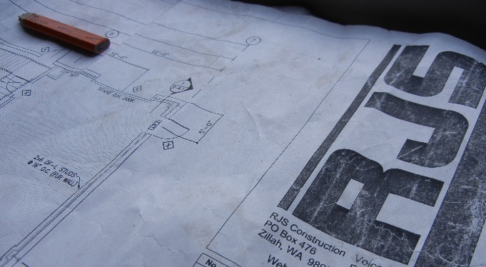
A belief in, and the pursuit of, good design is a philosophy of RJS and one that we insist is mutually valued by our design partners. We partner with firms that embrace the tenet that quality design begets facility functionality and longevity. While design, and determination of appropriate treatments, takes place at the beginning of a design-build project and the tangible aspects of construction take place toward the middle and end of a project, in reality both are intertwined. Therefore, the Design Team works in conjunction with the Construction Team throughout the construction process to ensure that design and building integrity and contract compliance with respect to design elements are carried forward from design and integrated throughout the construction process.
Our design-build project management is accomplished through quality control, scheduling, site management, budget controls, and communication among all teaming partners, planners and stakeholders. Our integrated project management approach involving engineers, designers, construction professionals and the client, from the schematic phase through contract close-out reinforces design goals and ensures the entire team is committed to the success of the project.
Effective project management requires strong internal controls to manage risk, establish accountability and maintain relationships. Development of clearly defined roles, responsibilities, and lines of authority is one of the first steps in putting these controls into place. Once roles, responsibilities, and lines of authority are established, the next step is to ensure that the right person, with the right skills, qualifications, and experience is assigned to the appropriate role. The result is a high performing team and a decision-making framework that assures streamlined contract process and “speed service delivery.”


Trusted design partners include:
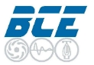

D2C Architects
CTA Architects Engineers
BCE Engineers
Guernsey Engineers Architects Consultants



Altman Browning & Company

Coffman Engineers
Galloway & Company, Inc.

Quality Control Plan
The RJS Quality Control Program (QCP) is founded on the standards of USACE and NAVFAC Quality Control Management programs. All RJS Superintendents as well as the QCM staff, receive training through the NAVFAC/USACE certificate program. The project specific QCP will be developed to ensure that all design and construction activities are conducted in a planned and controlled manner consistent with the design specifications and documents; that the product of these activities conforms to the contract requirements; and that the appropriate documentation exists to support each activity for which RJS is responsible.
Construction quality control will be assured through the use of the Three Phases of Control process and through the use of third-party material testing firms. The Three-Phase process includes inspections of work elements based on technical specifications applicable to each Definable Feature of Work (DFOW), during each of the three operational phases: Preparatory, Initial, and Follow-up.
Key elements of the RJS QCP include:
- Submittal and document control procedures.
- Preparatory meeting for each DFOW. Approved submittals, RFI’s, contract documents, manufacturer’s installation instructions, material safety data sheets and specific safety elements related to the definable feature of work and schedule are reviewed.
- Initial inspections are performed once work commences and follow up inspections are performed at the completion of each DFOW to verify that the work is being performed in conformance with the contract requirements.
- Deficiency tracking log will track and correct any deficient work in a timely manner.
- Daily photographs are taken to document covered work.
- Daily reports document work activities & quality control inspections and are mandatory.
- As-Built documents are updated and maintained throughout the progress of the project.
RJS will provide a project specific QCP that will include the following:
- Organizational structure
- Roles and responsibilities
- Submittal procedures
- Definable Features of Work
- Operational testing and commissioning procedures
Finishing strong is a key element to every successful project. This starts with implementing an effective QCP. Implementing the three-phase inspection program during construction will help avoid costly errors, mitigate reworking of work performed, and ensure a quality product delivered safely, on time, and within the budget. Once the punch-list is complete and inspected by RJS, we will schedule a prefinal walk through with the owner and design team. Any items generated from the prefinal walk through will be promptly corrected and we will schedule the final walk through to verify these items have been corrected.
We believe project closeout starts at the beginning of the project. We develop a closeout log and start gathering closeout documents during the submittal process. The only remaining items that will need to be gathered after the project is complete are the as-builts, warranties and commissioning reports.
Corporately, RJS' philosophy is that quality control is every stakeholder, user and worker’s responsibility. Therefore, the project team is empowered and encouraged to recognize, pursue and build quality into every phase of the project.

Customer Satisfaction
“Our sincere appreciation to RJS for the incredible flexibility shown to us in the numbers of re-scoping, short notice, and all the other problems you seemed so capable of overcoming to our benefit.”-Cynthia Markum and Jeffery Feeney, National Park Service, Intermountain Region
“The complexity of the two projects awarded to RJS Construction was high and required many specialty tasks. In addition, the fact that both projects had to be constructed in parallel increased the challenge. RJS utilized their own talents and the talents of several very capable subcontractors to more than meet our expectations in many areas. Their quality was exceptional, and they met or exceeded all of our required tolerances. They were also very cooperative and patient with scheduling and scope changes. Their attention to safety was paramount and better than most other contractors I have worked with. They also possess a very strong desire for customer satisfaction. They make every effort to accomplish all required tasking, regardless of unforeseen issues, without the necessity of change orders. All aspects of both projects RJS accomplished at the Yakima Training Center either met or exceeded requirements I cannot say enough about them as a prime construction contractor. Their professionalism, quality, technical expertise and ability to coordinate the efforts of multiple trades contractors is exceptional. It has been my experience that a company is only as good as it’s support. RJS is a family owned and operated company. Their work ethic, professionalism, quality and technical savvy trickles down from the top. Not only does the field workforce respect their management, they know that support is always there as soon as it is required. Therefore, from my experience working with RJS on these two projects, I would strongly recommend them without hesitation and look forward to working with them again.” -Carmen Foreman, Subcontract Administration for Assurance Technology Corporation for Joint Base Lewis-McChord-YTC Naval Research Laboratory
“(RJS Team) managed the project well and effectively communicated with the government throughout the project.”
-Rosa Krauss,
General Services Administration

“A good contractor to work with & brings a dependable team that gets the job done.” -Robert Roybal, General Services Administration
“We have been consistently pleased with the level of professionalism of [the RJS] staff, the dedication to providing a quality product, timely project completion and general ease of communication. One of the notable qualities of RJS...is their ability to coordinate sub-contractors and projects as a whole...they operate as a team member with the budgetary and functional requirements of the clients always given priority.” -Sherlyn M. Brockway & Allen G. Opfer, Brockway Opfer Raab Architecture, P.L.L.C.
“Contractor ranks high on capability and performance quality; quality work and ability to work with difficult stakeholders.” Matt Anderton, Trustee, Department of Agriculture
“I have known RJS for at least 12 years and over that time, our agency has chosen to work with them on a variety of projects. I have learned to trust them implicitly, knowing that they understand that we need to achieve the best possible results with often limited resources.” -Ron Harle, Manager, Hogue Management
“RJS Construction has outstanding quality control. What they build looks better and lasts longer than other contractors.”
-Burt Ross, Agri Beef Co.

Projects
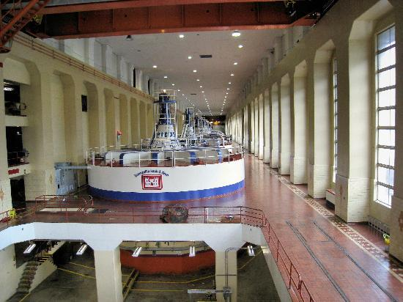
USACE – Bonneville Powerhouse 1 Control Room Fire Protection
Contract Summary
Contract Number | W9127N18C0021
Project Delivery | Firm Fixed Price
Contract Value | $4,144,684.00
Location | Bonneville Dam, OR
Project Duration: | 04/05/2018 - Current
Project Manager | Chris Boring
Owner | USACE Portland District  333 SW 1st Avenue  Portland, OR 97204
Owner’s  Representative | Thomas J. Cohick  (503) 808-4615  thomas.j.cohick@usace.army.mil

Project Description: RJS is the Prime Contractor on this current project consisting of implementation of fire protection safety improvements that include early detection and notification; developing an egress route for the control room staff; increasing the control room and egress route fire rating. The work includes design and installation of a fire alarm system that includes new fire alarm control panel, addressable intelligent fire alarm devices and aspirating smoke detection; replacing existing doors and hardware; increasing the fire rating of existing walls to a new 2-Hr rating around the control room; sealing of existing penetrations (including roof and floor); and installation of a new pressurization system for the control room. Electrical scope includes providing and installing conduit, wiring, and electrical equipment. Lighting scope includes all emergency lighting units, control room lighting fixtures and lighting installed in stairwell. Included are new fiber optics cable installation at terminations in Powerhouse 1 and Powerhouse 2. The project also includes hazardous material abatement. The project will require a temporary enclosure to be constructed around and above the existing control room and control room equipment to protect against damage during the control room work. Some work is required to be performed off hours.
Key Aspects:
- Prime Contractor
- Fire Protection & Alarms System
- Lighting
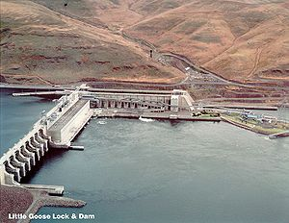
USACE - Little Goose Adult Fishway Controls
Contract Summary
Contract Number | W912EF-15-C-0008
Project Delivery | Firm-Fixed Price
Contract Value | $303,490
Location | Dayton, WA
Start Date | 12/01/2014 – 02/01/2015
Liquidated Damages | None
Design Firm | Design-Build
Project Manager | John Brouillette
Owner | USACE – Walla Walla District
Owner’s  Representative | Randy Mallo  (509) 527-7071  Randy.A.Mallo@usace.army.mil

Project Description: The intent of this project was to install a programmed system to maintain an equilibrium balance of velocity of flow & volume to mimic a natural habitat for native fish species in an adult Fishway at Little Goose Dam & Lock on the Snake River. The scope of work for this exciting design-build project included the demolition of the existing system and the design and installation of a weir gate monitoring and control system that allows for a (HMI) Human/Machine-Interface control screen, bringing four control stations to one location. Project included: Design and integration with existing control system, the installation of new multi-mode fiber optic cable, new Programmable Logic Controllers (PLC’s) and Sonic Proximity Sensors (SPS’s), Demolition of Existing Electrical and Control Equipment, Fiber Optics, Low & Medium Voltage Electrical, Software Development and Programming, Installation and Programming of Sonic Proximity Sensors and Transducers. RJS performed portions of the design and installation in house and managed subcontractor consultants. The Project required a field survey, partial reverse engineering, analysis of existing environmental variables, and development of (SOP) Standard Operating Procedures for calibration, setup, and training of the USACE staff on setup, calibration, operations and maintenance.
Key Aspects
- Prime Contractor
- Self-performance:
- Dam Construction: Six individual weir gates requiring individual monitoring and control, six individual water level monitoring points that provide level data throughout the system, (12) Siemens Hydrorangers, (12) Siemens Transducers
- Electrical: Mid & low voltage electrical demolition, 3500lf of fiber optic cabling
Flexibility & Problem Solving
- Scheduling Flexibility: Throughout the course of the project, there were several operational issues that impacted schedule. RJS proactively maintained contingency scheduling allowing schedule flexibility for the customer without causing delays or cost overruns.
- Project Enhancement: The customer had a concept of their desired functionality of the system. RJS researched specific end user requirements and developed a baseline setup and operation that achieved the end user requirements. RJS performed a laser control elevation survey to establish and determine relative elevations at all control and monitoring points throughout the system.

NAVFAC-B1950 Roof Replacement Naval Station Everett
Contract Summary
Contract Number | N44255-14R-6043
Project Delivery | Design Build
Contract Value | $1,158,000
Location | Everett Naval Station
Start Date | 09/30/2014 – 07/01/2015
Liquidated Damages | None
Project Manager | Richard Sevigny
Owner | Everett Naval Station  200 West Marine View Drive  Everett, WA 98207-5001
Owner’s  Representative | Contract Officer Dawn Malveaux (425) 304-3184  dawn.malveaux@navy.mil
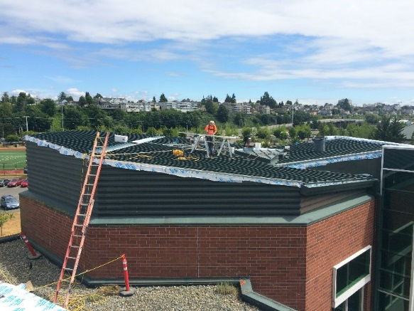
Project Description: This design-build project at Naval Station Everett consisted of removal & replacement of a 40,000sf standing seam metal roof system with additional insulation & waterproofing, removal & installation of bird deterrent. In addition to the standing seam metal roofing, system components included a redesigned/modified fall protection system, flashing including but not limited to fascia, ridgelines & troughs, 3” rigid board insulation, & a 22-gauge, stainless steel gutter & downspout system with factory applied color coating.
Although the original SOW required RJS to retain professional architectural services, this changed due to budget constraints. With a key subcontractor & roofing supplier, RJS performed design services in-house & delivered the project’s required design drawings & calculations. Misc. associated work included replacement of boots & flashings at all roof penetrations, painting of roof stacks, vent piping & caps, and redesign & modification of existing roof hatch door to accommodate hinged operation.
Key Aspects
- Prime Contractor
- Self-Performance: 18% -supervision, QC management, selective demo, painting, coatings, sealants, mechanical & electrical, disconnect/reconnect & alterations, fall protection design, & bird deterrent.
- Bird Deterrent: Environmental challenges with existing bird deterrent included birds being tangled in wires on high areas of the roof where the birds would eventually die. RJS presented a value engineering option of a programmable area specific non-lethal laser deterrent system.
- Craning: Long runs & critical load crane support was required. Specific crane plans & submittals were required. Design of Crane Plans & field coordination were significantly complex.
Flexibility & Problem Solving
Extreme Weather Conditions: Severe weather events during tear off demolition created areas of moisture intrusion. RJS QC Manager requested a Thermal Imaging Inspection/Report to verify that all moisture was evacuated from roof, areas of moisture intrusion were corrected & did not create damage.
Occupied Space: Public building ingress/egress was on all sides of the building, which is directly adjacent to athletic fields; events, use of restrooms, shower facilities, restaurant, pub and dining facilities is frequent. Public safety was a concern & logistical challenge, RJS had no safety incidents. NAVFAC had several requests to work around events that were to take place at the facility. Just two hours after approved laydown areas was delineated in the field, NAVFAC requested the laydown area be temporarily returned to normal use and all fence and delineators removed. RJS obliged at no cost.

Value Engineering: On several occasions including the initial contract negotiation, RJS provided value engineering solutions to meet the client budgets. RJS finished approximately two months ahead of schedule, providing cost savings to the client.
Fairchild Air-Force Base – FY15 Airfield Striping
Contract Summary
Contract Number | FA4620-14-D-B004-0004
Project Delivery | Bid Build
Contract Value | $619,318
Location | Fairchild Air-Force Base
Project Duration | 04/16/2015-11/05/2015
Liquidated Damages | None
Project Manager | Stan Gilmore
Owner | Dept. of the Air Force/92 Sq.  110 W Ent Street  Fairchild AFB, WA 99011-8568
Owner’s  Representative | Justin Hayes  (509) 247-4885  justin.hayes.2@us.af.mil

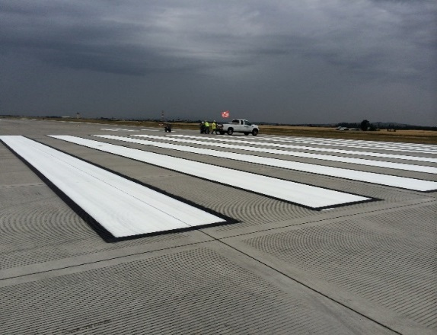
Project Description: RJS was the Prime Contractor for complete removal of painted markings and blackout of painted markings. RJS captured, analyzed, and disposed of all associated debris and wastewater; controlled particulate matter during paint removal; method(s) of waste characterization; and helped determine capture and disposal methods. To avoid damaging the asphalt, all paint removal on asphalt pavements was done by grinding. RJS laid out work for new markings on specified areas of the airfield; provided traffic paint, reflective media and non-skid media in designated areas; provided two coats of paint on all new paint areas and areas where paint was removed and being replaced; provided one coat on areas with existing paint (not being removed); protected traffic paint until dry and hardened sufficiently to withstand traffic. Several government employees, including Contracting, CE, and Airfield Management, stated that the quality was top notch and the best they have seen in years. It was further, specifically stated that this was the best striping project the end user had to date.
Key Aspects
- Prime Contractor
- Self-Performance: 20%
- Renovation/Alteration/Repair
- Pavement and Pavement Markings: 395,300sf of reflective painting, 256,200sf of non-reflective painting, and 5,600sf of paint removal. RJS also took the time to fix areas that were incorrect from previous painters.
- Site Work: This included, site supervision, quality control, transportation of equipment from taxiways, street sweeping, cleanup, and torch-down.
Flexibility & Problem Solving
Communication: By maintaining continuous communication with Flight Line personnel RJS was able to maximize production efforts, earning the praise of the end user.
Scheduling: When the delays of another onsite contractor held up the RJS work plan, RJS scheduled around their delay so as not to inconvenience our client. Work was performed on a night and weekend schedule to avoid runway closure.

National Park Service – Gros Ventre Road Stabilization
Contract Summary
Contract Number | P17PD03056
Project Delivery | Bid-Build
Contract Value | $781,389
Location | Grand Teton NP, WY
Duration | 09/29/2017 – 11/20/2017
Liquidated Damages | None
Project Manager | James (Rick) Andrews
Owner | NPS – Northern Rockies  PO Box 168 Yellowstone NP, WY 82190
Owner’s Representative | Martin Hauch  (307) 739-3348  martin_hauch@nps.gov
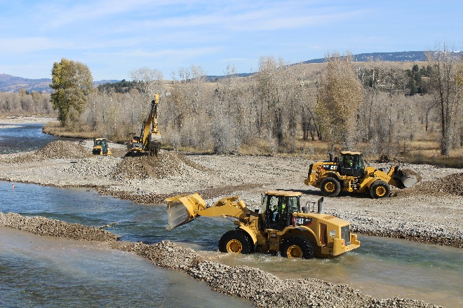
Project Description: RJS was the Prime Contractor for roadway subbase construction, base prep with asphalt paving, and the armoring of the river, with riprap and stream barbs. The contract included 75% self-performance and consisted of constructing a paved bypass where a road had washed out and armoring the bank to prevent further erosion. The work on the road required construction of 900ft of road including managing the flow of traffic during all phases of construction. The surface had to be raised several feet in some locations to support the new road alignment. The contract included the construction of one drainage culvert under the road. The project also required armor 450ft of eroded stream bank using 2000 cubic yds of riprap and the construction of three stream barbs. The period of performance was only 60 days form the notice to proceed.
Key Aspects
- Prime Contractor
- Self-Performance: RJS Self-Performed: 75% Prepped/graded for paving, prepped revetments, placed rip rap on revetments and constructed coffer dams and stream barbs.
- Site Work, Clearing, Grubbing, Grading, and Landscaping
- Roadway Construction/Repair

Flexibility & Problem Solving
Design: During the river bank armoring phase of the project, RJS assisted the park in quickly and effectively navigating some challenging design issues. The original survey was inaccurate and proved to be impossible. RJS assisted the park in coming up with a revised plan for the execution of the armoring. While waiting for the revised contractual direction RJS continued to move forward on all other work.
Environmental Issues: RJS needed to be conscious of the existing flora, and minimize the impact the project was having as well as the removal of any deconstructive residual evidence.
Challenging Site Conditions: Project was predicated on preventing the river from further eroding the existing revetment, which was undermining the foundation of the access road.
Traffic Control: Traffic Control was a constant issue, due to the fact that the area was sparsely populated, yet the access road was heavily used, leading to the potential for dangerously speeding vehicles. RJS needed to keep at least one lane open at all times, as this was the main thoroughfare for the area.

BOR – Entiat Infiltration Gallery
Contract Summary
Contract Number | R17PC00106
Contract Value | $3,131,072.93
Location | Entiat National Fish Hatchery,  6970 Hatchery Rd  Entiat, WA
Start Date | 10/20/2017 – In Progress
Project Manager | Stan Gilmore
Owner | Bureau of Reclamation, Pacific Northwest Region
Owner’s Representative | Donald Riger  (208) 378-5224  driger@usbr.gov
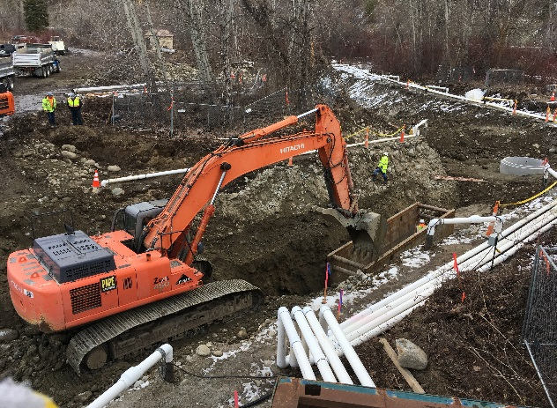
Project Description: RJS Construction, Inc. is constructing an infiltration gallery at Entiat National Fish Hatchery to supplement the hatchery’s disease-free well water supply. The infiltration gallery consists of 300 lineal feet of deep buried horizontal well screen and filter pack material, including open trench excavation, dewatering, and precast structures and piping for cleanouts; a manhole pump station with two vertical turbine pumps, a wood-frame building, plumbing, electrical and HVAC. The project also includes a concrete aeration chamber including a packed column aerator and control gates; PVC piping including buried pipelines between the pump station and the new aeration chamber, connections between the new aeration chamber and the existing aeration chamber, Bank A raceways, sand settling basin; replacement of a segment of an existing 30-inch buried concrete pipeline with 30-inch PVC pipeline a PVC pipeline connection providing groundwater supply to the adult pond; and electrical connections for the new pump station.

Specifics include: 3 manhole structures, one 27ft deep, 450lf of 14” diameter stainless steel pipe and infiltration bedding, 550lf of 18” pvc-pipe from the new pumphouse to the aeration chamber. The new pumphouse houses two 4000gal per min vertical turbine pumps, flow meters, controls and the 96” diameter 27ft deep collection well. The whole system was integrated into the existing fish hatchery systems to provide water to the hatchery to supplement the well system already in place. The site had to be cleared of trees and vegetation and dewatered to a depth of 5ft below the stainless-steel pipe elevation. The dewatering system included 16 wells to a depth of 30ft with a 6” manifold system delivering water to 2 – 18,000gal baker tanks.

Key Aspects
- Prime Contractor
- Piping
- Removal & Installation of Equipment

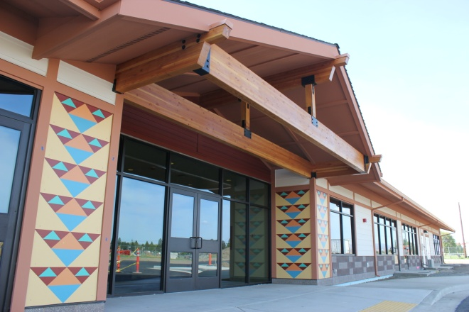
Yakama Nation - Legends Casino Childcare Facility
Contract Summary
Contract Number | SB-12291003
Project Delivery | GMP
Contract Value | $2.5 Million
Location | Toppenish, WA
Duration | 10/01/2012 - 04/01/2013
Liquidated Damages | None
Design Firm | Bergman Walls & Associates
Project Manager | Richard Sevigny
Owner | Yakama Nation  401 Fort Road  Toppenish, WA 98948
Owner’s Representative | Greg Evans, SB  (425) 283-5254 gevans@swinerton.com
Project Description: RJS Teamed with Swinerton Builders for the Legends Casino $105M casino and hotel expansion. The first phase of this expansion was this new 11,175sf childcare center. RJS was the prime contractor for the single story, slab-on-grade building. The facility had rooms designed for infants through 12-year-old children, a nurse’s station, laundry, kitchen, reception, and staff offices. The exterior of this building incorporated Native American designs and architectural features at the entrance, gable ends, and dormers. This project also included a fenced in play area, asphalt driveway including 23 parking spaces, sidewalk, curb and gutter, irrigation, and landscaping.
Key Aspects
- Prime Contractor
- Self-Performance: Self-performed the site improvements, earthwork, utilities, hardware install and finish carpentry.
- Features: Fire suppression system, alarm system, utility infrastructure and services, IT, wood framing, architectural roofing, Hardi-plank siding, and anti-graffiti treated masonry.
- Site Work: Asphalt paving, landscaping, playground & play equipment, basketball court, and bio-swale.
- Interior Finish: Pinch-proof hinges, scratch resistant wall paper, acoustical ceiling tile, skylights, ceramic & carpet tile, folding accordion door, commercial kitchen, & custom casework.
Flexibility & Problem Solving:
Building Authority: Yakama Nation doesn’t have a Building Department or Code Enforcement. RJS contracted with a third party for a “peer review” plan review & conducted site inspections.
Poor Soil Condition: A high water table and low bearing capacity for existing soil required dewatering, over-excavation and placement of compacted gravel under foundations.
Design Challenges: RJS was given “Notice to Proceed” before final Construction Drawings were available. In order to keep the project moving, RJS hosted a weekly owner’s meeting that included the owner’s representatives and the design team. Exterior brick veneer, fiber cement board trim and soffit material created a durable, low maintenance exterior package. Anti-graffiti veneer masonry was provided to help protect the exterior of this building.
Customer Satisfaction: RJS has since completed projects for several Yakama Nation entities, including: Yakama Power, Yakama Nation Diabetes Program & Yakama Nation Fisheries.

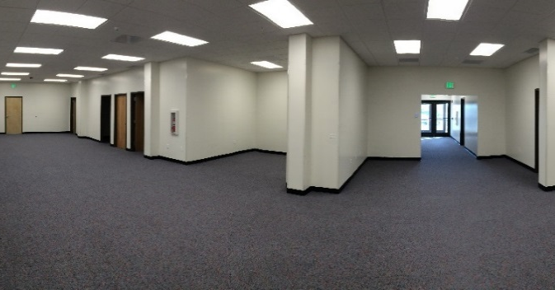
Fairchild Air-Force Base – Relocate USACE Office
Contract Summary
Contract Number | FA4620-14-D-B004-0009
Project Delivery | Design-Build
Contract Value | $562,466
Location | Fairchild Air-Force Base
Duration | 01/11/2016 – 09/30/2016
Liquidated Damages | None
Project Manager | Stan Gilmore
Owner | Fairchild Air Force Base  Building 2451  FAFB, WA 99011
Owner’s Representative | SSgt Justin Hayes  (509) 247-4885  justin.hayes.2@us.af.mil

Project Description: Provided new office spaces complete with heavy use finishes, new gas HVAC unit for office area (approx. 3200sq.ft.) and new entry way into the building. Rebuilt vestibule to match existing building. Furnished and installed suspended ceilings, walls cove base and lighting, corner guards, carpet tiles and other finishes. Upgraded electrical system and provided new panels to accommodate updates to floor plan, HVAC mechanical system, fire alarm/fire suppression system, and lighting layout.

Key Aspects
      - Prime Contractor
      - Self-performed 35% - including demolition, doors and insulation.
- Work included drywall, light gage metal framing, paint, carpet, metal door interior doors and frames, aluminum storefront doors & windows, acoustic ceiling tiles, rubber base, demo of walls, asbestos tile and lead paint abatement, fire suppression system upgrades and casework.
- New standing seam metal roof & siding - infill windows & patching of existing siding to match.
- New split unit and roof-top HVAC units - New secondary electrical panels.
- New door penetrations through existing walls.
- Demolition, Renovation, Alteration & Repair
- Mechanical
- Electrical
- Roofing
Flexibility & Problem Solving
Design: The floor to ceiling wall on the approved design left an odd shape in the main office area. RJS suggested a no cost modification to the customer layout, improving the overall usability and visual appeal of the space. Government furnished cubicle layout shifted during construction causing a conflict with a door swing into the main hallway. RJS modified the layout and door schedule to accommodate. As-builts were missing columns discovered during demo. RJS switched the location of a storage room and a conference room to ensure the conference room was free of interior columns.
Occupied Space: Low noise and no issues with dust control in a fully occupied space.

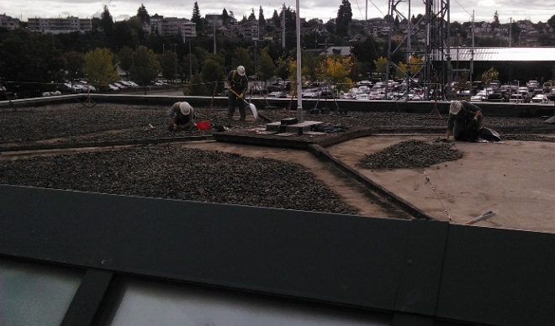
NAVFAC – Everett Naval Station Re-Roof B2114
Contract Summary
Contract Number | N44255-14-R-6017
Project Delivery | Design-Build
Contract Value | $168,209
Location | Everett Naval Station
Duration | 05/21/2014 - 09/22/2014
Liquidated Damages | None
Design Firm | RJS Construction, Inc.
Project Manager | Richard Sevigny
Owner | Everett Naval Station  200 W Marine View Dr  Everett, WA 98207-5001
Owner’s Representative | Kyle Bringedahl  (425) 304-4502  kyle.bringedahl@navy.mil

Project Description: RJS was the Prime Contractor for this Design-Build project which consisted of the tear off and replacement of a 9,000sf built up, non-adhered EPDM, ballasted roof system on the Fire Safety Building located at the Everett Naval Station. The existing roof system had deteriorated due to water intrusion and had outlived its usable life span. The scope included the complete replacement of the entire flat roof systems on both the East and West sides of an existing glass atrium and involved ballast removal and replacement, flashing, EPDM membrane, and the replacement of the associated rigid roof insulation. Additional work elements included design, fabrication, and installation of shroud assemblies to fit over two (2) existing louver structures on the east side of the existing apparatus bay, construction of a new HF antenna ground mount base, cleaning both the interior and exterior surfaces of the skylights and atrium associated with the building, and cleaning all scuppers and downspouts associated with the building roof system to ensure proper flow and diversion of water off the new roof surface.
Key Aspects:
- Prime Contractor
- Self-Performance: RJS self-performed 31% of this contract including design and installation of the new shroud assemblies, painting of all roof exhaust hoods, hatches, and miscellaneous penetrations within the roof footprint, cleaning of the atrium windows, cleaning and scraping of the existing skylights, quality control, and safety oversight.
Flexibility & Problem Solving:
Occupied Space: Removal of the existing ballast required protective measures to prevent air pollutants from migrating into occupied spaces and exposing building occupants to harmful dust and debris. RJS accomplished this through tarping building faces and sealing all HVAC intakes and vents with 6mil. plastic sheeting and duct tape.
Environmental Regulations: Compliance with complex environmental regulations included consultation with the Washington State Department of Fish and Wildlife to avoid disturbance of native gull species that nested on the roof in the overnight hours during the construction phase.

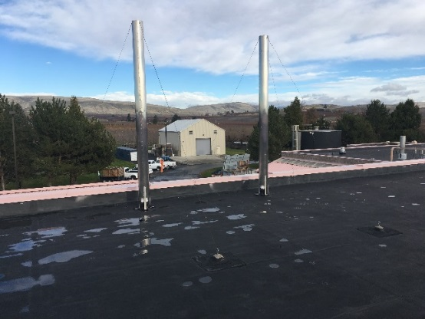
USDA – TTFVR Roof & Cooling Tower
Contract Summary
Contract Number | AG-32SD-C-16-0060
Project Delivery | Design Build
Contract Value | $314,746
Location | Wapato, WA
Start Date | 09/30/2016
Completion Date | 04/19/2017
Liquidated Damages | None
Project Manager | Richard Sevigny
Owner | USDA ARS WBSC
Owner’s  Representative | Washingtoni  (510) 559-5604  Washingtoni.NLN@ARS.USDA.GOV

Project Description: RJS was the Prime Contractor for this multi-phased, Design-Build installation of a new thermoplastic polyolefin (TPO) Membrane over the existing Ethylene Propylene Diene Terpolymer membrane (EPDM) roofing system & installation of a new EVAPCO cooling tower to replace an existing unit at USDA, ARS, Temperate Tree Fruit & Vegetable Research (TTFVR), Wapato. The USDA Research Facility housed temperature & moisture sensitive agricultural specimens that contained over $1M worth of inventory & it was crucial to keep the weather conditions in check. RJS coordinated the cooling tower replacement & roofing upgrades to ensure that temperature & moisture contents in the facility remained within specific, sensitive parameters.
Key Aspects
- Prime Contractor
- Self-Performance: Self-performance on this project included: touch-up painting, misc. demolition, misc. sheet metal repair, misc. electrical, rough and finish carpentry.
- Fluid Cooler: Removal of existing fluid cooler, installation of one new Evapco model ATW45B fluid cooler, one rental fluid cooler set up on the trailer during change out, misc. piping to connect new cooler to existing piping, addition of 30% polypro glycol to new water, addition of pipe to reach the temp fluid cooler.
- Disposal of Existing Tower
- Craning
Flexibility & Problem Solving
Value Engineering: The client originally requested a price for an elastomeric roof coating. After consulting with several roofing contractors & design firms, RJS concluded that the best option was to leave the existing EPDM roof system & cover it with a new TPO Membrane. By switching to this design specification, RJS saved the client over 30% of construction costs.
Weather Conditions: The changes in design made by RJS allowed construction to take place during the wet season of the year without having to remove the existing roofing. This approach prevented exposing the occupied building to potential leaks and damages.
Project Enhancement: During the pre-award project phase, RJS found that previously installed heat-trace & electrical conduits on the roof were not per state electrical code. RJS worked with the client to remove & replace these items. To save on labor costs, RJS partnered with the client to utilize the time & expertise of facilities maintenance staff to remedy the issue.

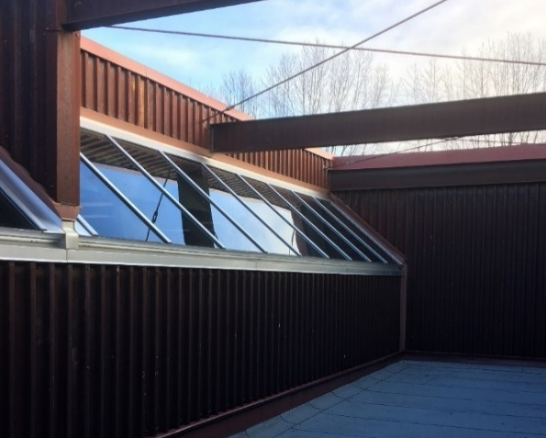
Bureau of Indian Affairs – Interior Restorations and Roof Repairs
Contract Summary
Contract Number | A16PC00128
Project Delivery | Design-Build/Negotiated
Contract Value | $696,467
Location | Salem, OR
Project Duration | 06/23/2017 – 09/08/2017
Liquidated Damages | None
Project Manager | Chris Boring
Owner | Bureau of Indian Affairs  911 NE 11th Ave  Portland, OR 97232
Owner’s Representative | Kevin Kelly  (503) 231-2279  Kevin.kelly@bia.gov

Project Description: This design-build project consisted of a water leak investigation and temporary repair work to mitigate water damage to the interior finishes. The damages were mainly in the administration offices and classrooms. Project scope of work also included the removal and replacement of an epoxy coating on an elevated roof deck over the administration area, the removal and replacement of an existing built-up roof system over classrooms, the removal and replacement of a custom skylight system, new carpet, new LED light fixtures, drywall, ACT ceiling, painting and modifications and integration to the existing fire alarm and fire sprinkler systems. The new security and fire suppression systems needed to be integrated with the existing control systems.
Key Aspects:
- Prime Contractor
- Self-Performance: Self-performed 25% of the work on this project including selective demolition, framing, sheathing, supervision and quality control.

- Demolition, Renovation, & Repair
- Interior Finishes
- Painting
- Mechanical
- Electrical
- Roofing
- HVAC
- Thermal and Moisture Protection
- Drywall- Paint and Finishes
- Fire Suppression/Alarm

Flexibility & Problem Solving
Security: Chemawa is an Indian Boarding School that houses students on campus during the school year full time. Background checks & badging were required for student safety. RJS proactively had employees, management staff, & subcontractors approved to work on the site weeks before project began to ensure safety, security, and timeliness.
Occupied Space: Administration Offices were occupied during construction
Fast Track Schedule: Project needed to be complete during summer before return to school.
Design: RJS and their design team met on site with the BIA Contracting Group and the BIE’s local staff to determine the Scope of Work for the project. Several items on the original budget were verified after selective demolition and the design was later modified with that information. Much of the final design specifications, including fire & alarm system integration were developed by the RJS subcontractors and then approved and included by the design team.
Catholic Charities – New Early Learning Center
Contract Summary
Contract Number | 21.0116
Project Delivery | Design-Assist
Contract Value | $3,766,692.99
Location | Yakima, WA
Start Date | 07/19/2016 – 08/25/2017
Liquidated Damages | None
Design Firm | BOR Architects
Project Manager | Scott Shald
Owner | Catholic Charities  5301 Tieton Drive,  Yakima, WA 98908
Owner’s  Representative | Darlene Darnell  (509) 965-7100  ddarnell@cfcsyakima.org
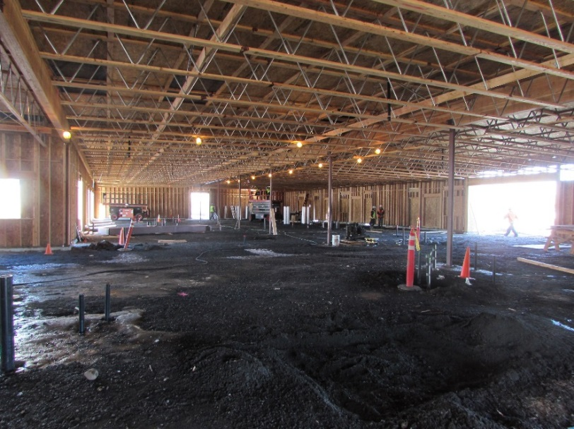

Project Description: RJS was the Prime Contractor on this Design-Assist 16,750sf, wood frame, slab on grade building for the Catholic Family Child Services. Scope included TPO roofing, standing seam roofing, security access control, asphalt & concrete paving, Building Automation System (BAS), infiltration system, architectural metal & EIFS siding, fire suppression and alarm, water, sewer & electrical utilities. This state-of-the-art early learning facility, includes administration offices, classrooms, medical exam, library, and playground, specifically designed and constructed to care for the unique needs of infant and preschool children. From the specialized heights of the cabinetry and bathroom facilities, to the brightly colored finishes and open play spaces, as well as the electronic security and safety monitoring systems, this project has been built to suit the needs of this unique customer base.
Key Aspects
- Prime Contractor
- Self-Performance: 22% including contaminated soil remediation, project supervision, quality control management, over 20,000sf concrete forming and placement, and miscellaneous & finish carpentry.
- New Construction
- Multiple Disciplines: HVAC; Electrical; and Mechanical
- Fire Protection
- Paving & Pavement Markings
- Concrete & Sidewalks
- Parking
- Landscaping
- 26 Subcontractors Managed
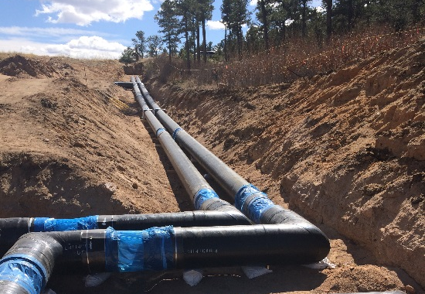
USAF – High Temp Hot Water Lines Phase 3
Contract Summary
Contract Number | FA7000-15-C-0048
Project Delivery
Contract Value | $1,202,157
Location | USAF Academy Colorado
Duration | 07/10/2015
Liquidated Damages | None
Project Manager | Robert Billings
Owner | USAF Academy Colorado
Owner’s Representative | Ken Helgeson  (719) 333-3777  kenneth.helgeson.3@us.af.mil

Project Description: The High Temperature Hot Waterline Pipe Replacement Phase 3 at the high-profile United States Air Force Academy was performed by RJS Construction. The project consisted of installing 450lf of HTHW Pipe into a very crowded and active utility corridor running across the base at the USAFA. The project involved interfacing with not only the phase 2 contractor but also abating and removing approximately 300lf of existing ACM waterline after the new line was installed. While this project was just under 1.3 million, the challenges of integrating with the previous ongoing phases, as well as coordinating shutdowns with the base wide heat-plant made this a very complicated project.

USACE-Walla Walla District – Lower Granite Fishway Controls
Contract Summary
Contract Number | W912EF-16-P-5009
Contract Value | $494,761
Location | Lower Granite Lock and Dam, Pomeroy, WA
Start Date | 12/19/2015 – 06/09/2016
Liquidated Damages | None
Design Firm | FEAT Engineering
Project Manager | Richard Sevigny/John Brouillette
Owner | USACE- Walla Walla District
Owner’s Representative | Matthew Reeves, Contracting Officer  (509) 527-7060  Matthew.A.Reeves@usace.army.mil
Project Description
This design-build project included the design and installation of a weir gate monitoring and control system. This new system included PLC’s, SPS’s, fiber optic lines, original programming and software design. A short indefinite work window nescessitated the implementation of the RJS QCP that was utilized throughout project design and construction ensuring a successful and timely project delivery.

Manufacturing and Fabrication:
USACE - Bonneville Dam Shaft Sleeves
Contract Summary
Contract Number | W9127N-16-P-0164
Contract Value | $124,261.62
Location | Bonneville Lock and Dam  Cascade Locks, OR
Project Duration | 09/27/2016 – 12/19/2016
Owner | US Army Corps of Engineers,  Portland District
Owner’s Representative | Kathryn Newhouse  (503) 808-4620  Kathryn.a.newhouse@usace.army.mil
Project Description
RJS provided fabrication and delivery of 2 main unit shaft sleeves, 1 fish unit shaft sleeve, and 1 fish unit clamp ring.

USACE– McNary Fishway Entrance Stoplogs
Contract Summary
Contract Number | W912EF-15-C-0015
Project Delivery | Bid-Build
Contract Value | $855,000
Location | McNary Dam, Umatilla/Benton County, WA
Duration | 04/13/2015 – 06/15/2016
Liquidated Damages | None
Project Manager | Richard Sevigny/John Brouillette
Owner | USACE –Walla Walla District
Project Description
Fabricate and transport mock-up stoplog; perform on-site fit test; fabricate and deliver 12 Fishway Entrance stoplogs and return final mock-up stoplog and dispose of existing Fishway Entrance stoplogs.

